**🎓 Student-Oriented Needs Assessment Questionnaire**

*(Targeted toward students who experience essay-based grading and might interact with an AI-assisted grading system)*

🎉 **Congratulations!** You've been randomly chosen (*lucky you!*) to help us improve essay grading using AI—yes, robots **MIGHT** read your writing. 🤖

Please answer the following open-ended questions honestly; your insights matter more than your grammar (well, mostly). Your responses may be used for *Natural Language Processing (NLP)* training strictly within this Capstone Project.

No names, no leaks, no selling your thoughts to shady apps—we respect your data like a final exam answer key.

Alright, let's get serious (*kinda*). Start writing below:

|  |  |
| --- | --- |
| “How would you feel if an AI system helped check your essays but your teacher still gives the final grade?” |  |
| “What concerns do you have about fairness when an AI helps grade essays or written outputs?” |  |
| “Would you want to see how the AI evaluated your essay (e.g., comments, scoring breakdown)? Why or why not?” |  |
| “Would faster grading and feedback through AI make you feel more confident or anxious about your results?” |  |
| “What would make you trust an AI grading assistant to be fair and accurate with your essays?” |  |
| “Would you use an AI grading assistant as a practice tool to check and improve your essays before final submission?” |  |
| Have you experienced unclear or unfair human grading before? Do you think AI might do better or worse? |  |

🎯 **PART 2: The Shading Ritual (a.k.a. Bubble Answer Sheet)**

Welcome to the *"feelings section"* — where you get to express your deepest emotions... by filling in **bubbles** from **D *(Ew, no thanks)*** to **A *(Shut up! and take my Money).***

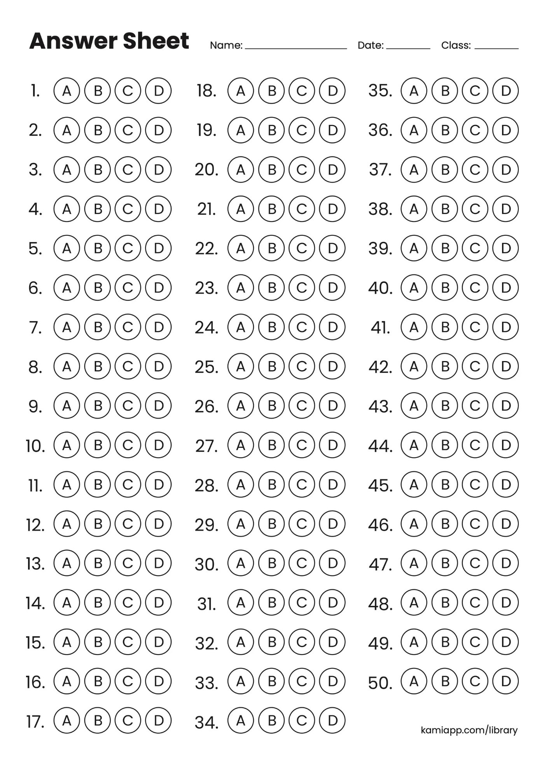Each question wants to know how much you *vibe* with the idea of AI + Teachers working together to grade your essays. Also, yes... your answers **might be used to train our OCR system**, so please **shade clearly** *unless you want our scanner to cry in binary*.So grab a pen (no pencils please), take a breath, and throw some Shade on those circles.

🙁

😊

|  |  |
| --- | --- |
| 1. *I like the idea of getting my essay graded faster using AI assistance.* | 1. *If the AI provides useful comments, I would use it to improve my drafts before final submission.* |
| 1. *I would feel comfortable if AI is used in grading, as long as the teacher gives the final grade* | 1. *I think having AI support will reduce the workload of teachers.* |
| 1. *I believe an AI grader could help make grading fairer and more consistent* | 1. *I would feel anxious if an AI had full control over my grades.* |
| 1. *I would trust the feedback from an AI-assisted grading system* | 1. *I support the development of AI tools to improve essay grading in our university.* |
| 1. *I prefer seeing exactly how my essay was evaluated (e.g., AI breakdowns or scoring feedback)* | 1. *I am excited to try out a grading system that uses both AI and human feedback.* |